Reviewed by: Hilda Coulsey

Date: 6th February 2021

Review in 2024 or when new UK Athletics guidance is issued.
Ilkley Harriers Code of Conduct for Athletes

This code of conduct should be followed at all times when you are involved in athletics (at training, team events and races whether participating or watching)

- Always treat everyone, athletes, coaches and others involved in the sport equally with respect, politeness and fairness.
- Uphold the values of sportsmanship on and off the field and cooperate with others in the sport.

As a responsible Athlete you will:

- Act with dignity and display courtesy and good manners towards others, avoid swearing and abusive language and irresponsible behaviour including behaviour that is dangerous to yourself or others, acts of violence, bullying, harassment and physical and sexual abuse.
- Not do anything illegal or irresponsible.
- Challenge inappropriate behaviour and language by others, consistently promote positive aspects of the sport such as fair play and never condone rule violations
- Thank those who help you to participate in athletics.
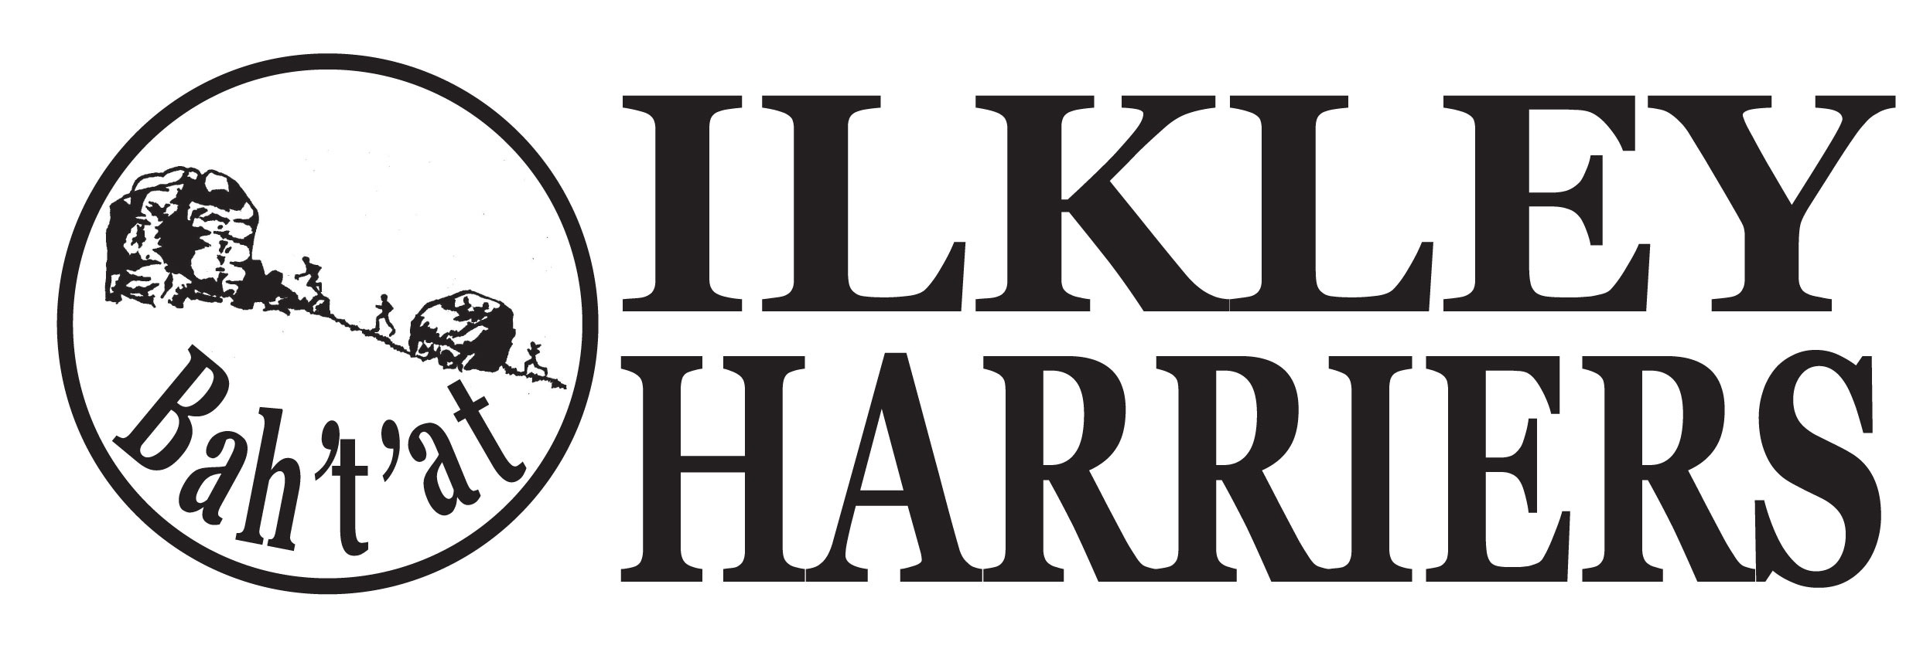
- Be organised with your equipment, wear appropriate clothing, remember medication you may need, fluids & food etc and arrive in good time.
- Behave sensibly, appropriately and safely and listen to advice and instructions carefully.
- Inform a coach if you are unwell or injured.
- Inform the club of any other coaching you are receiving.
- Be patient and calm, accept the decisions of the judges, coaches etc - do not argue or swear. If you feel you have been wronged, discuss it, calmly, with a coach or team manager.
- You are not obliged to answer any questions which are not related to athletics and your well-being related to athletic activity from coaches or officials. Coaches or officials may wish to discuss your well-being with you, confidentially, if they have a concern.
- Keep a clear boundary between friendship and intimacy with a coach, official or other person that you work with.
- Report any accidental injury, distress, misunderstanding or misinterpretation to your parents/carers, if applicable, and/ or club Welfare officer* as soon as possible.
- Report any suspected misconduct by coaches or other people involved in athletics to the club Welfare officer * as soon as possible.
Parents/ carers: We expect parents and carers of those athletes under 18 and of vulnerable adults to abide by the points above, with more specific detail in the British Athletics Code of Conduct for parents referenced below. A parental consent form must be completed for under 18s (website membership page)

- welfare@ilkleyharriers.org.uk

Reference:
https://www.britishathletics.org.uk/wp-content/uploads/safeguarding/Code-of-Conduct-for-Athletes-2020.pdf
https://www.britishathletics.org.uk/wp-content/uploads/safeguarding/Code-of-Conduct-for-parents-2020.pdf

