Reviewed by: Hilda Coulsey

Date: 6th February 2021

Review in 2024 or when new UK Athletics guidance is issued.

Ilkley Harriers Club Code of Conduct

The club will:

- Adopt national welfare policies and procedures, adhere to the codes of conduct and respond to any suspected breaches in accordance with these procedures
- Appoint a welfare officer and ensure that they are provided with appropriate training to act as a first point of contact for concerns about welfare issues
- Respect equally the rights, dignity and worth of every club member and others involved in athletics
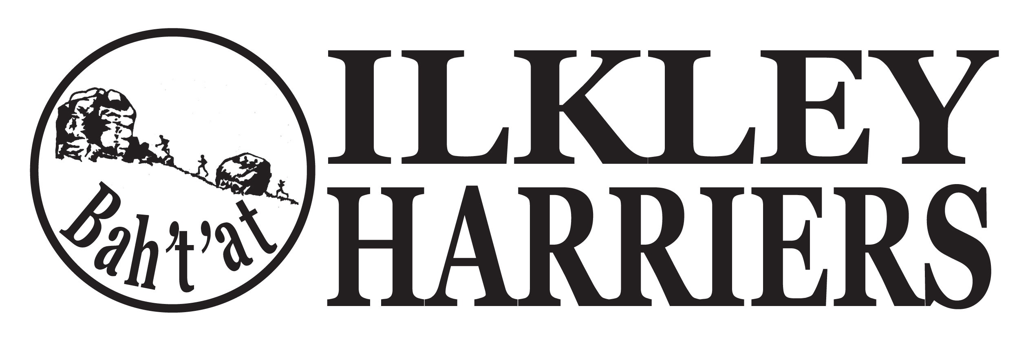
- Ensure that club officers and volunteers act responsibly, set an example to all members, follow good practice in maintaining the welfare and safety of members, challenge inappropriate behaviour and report suspected misconduct through the appropriate channels
- Ensure that all volunteers operating within the club environment hold the appropriate qualifications and have undertaken the appropriate checks e.g. DBS if leading running groups
- Liaise appropriately with key people eg parents/carers, national governing bodies and other relevant people/organisations to ensure that good practice is maintained
- Ensure that information is available at the club regarding contact details for local charities and support services, social services, the police etc.

https://www.britishathletics.org.uk/wp-content/uploads/safeguarding/Code-of-Conduct-Club-2020.pdf

